REQUEST FOR
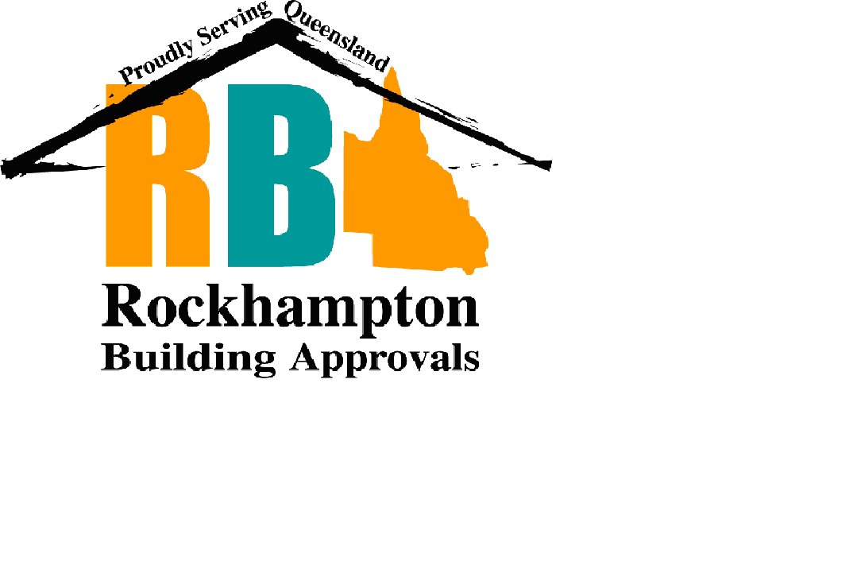

FIRE WALL

INSPECTION

Site Address:
Lot and Plan Description:
Applicant:
Applicants Phone No:
Applicants Postal Address:

Owners Name:
Owners Address:

Number of Units:
Access to Roof Space has been arranged: | Yes / No (In order for this inspection to be conducted the roof sheeting needs to be lifted)
Are Smoke Alarms Fitted to the premises: | Yes / No
Have the application fees been paid? | Yes / No  Amount Paid:

